NUT 201
Food is any substance consumed to provide nutritional support and energy to an organism. It can be raw, processed or formulated.
Foods have various characteristics which are features or qualities that differentiate foods from one another. They include physical, chemical characteristics etc.
Physical characteristics are outward properties of food like colour, texture, size, structure, viscousity, etc while chemical characteristics refer to nutrients in the food.
Classification of food based on
1. Nutrients
2. Function
3. Agronomic features
Nutrients are active chemical components in food that have specific structural or functional role in the body’s activity. Types of nutrients are proteins, fats, carbohydrates, vitamins, minerals and water. Almost all foods are a mixture of nutrients. Nutrients can be classified into Macronutrients and Micronutrients. Macronutrients are nutrients needed by the body in large amount, they are carbohydrate, protein and fat. They are the main source of energy to the body thus, they are referred to as energy yielding nutrients. Micronutrients are nutrients needed by the body in small amount, they are vitamins and minerals.

NUTRIENT REQUIREMENTS
What are nutrient requirements?
The amount of each nutrient needed to maintain health and reduce the risk of diet-related diseases is called the nutrient requirement. These are different for each nutrient and vary between individuals and life stages, for example women of childbearing age need more iron than men.
Why do nutrient requirements vary?
Each nutrient has a particular series of functions in the body; some nutrients are needed in larger quantities than others. For example, protein is needed in gram (g) quantities. Vitamin C is needed in milligram (mg) quantities (1/1000 gram) and vitamin B12 is needed in microgram (µg) quantities (1/1000000 gram). Individual requirements of each nutrient are related to a person’s age, gender, level of physical activity and state of health. Also, some people absorb or utilise nutrients less efficiently than others and so will have higher than average nutrient requirements, for example among older people, vitamin B12 absorption can be relatively poor.
Standards for nutrient intake - refers to various criteria for assessing food and nutrient intake of Population groups. These include: Dietary Reference Values (EAR, RNI, LRNI and SI) and various dietary/food guides, i. My pyramid food guide system, ii. MyPlate, etc… iii. Dietary guidelines for different countries
DIETARY REFERENCE VALUES (DRVS): DRVs are estimates of the requirements for groups of healthy people. They are guides that help in determining the amount of nutrient to be consumed on a regular basis by healthy individuals. Meaningful estimates of nutrient requirements must consider the distribution of requirements within a population or group. To achieve this, four Dietary Reference Values (DRVs) were set.
- Estimated Average Requirement (EAR): This is an estimate of the mean daily level of nutrient intake to meet the need of 50% of healthy individuals in a stage of life and a gender group i.e. 50 % of a group of people will require less, and 50% will require more. For a group of people receiving adequate amounts, the range of intakes will vary around the EAR.
- Reference Nutrient Intake (RNI) or Recommended Dietary Allowance (RDA): The RNI is the amount of a nutrient that is enough to ensure that the needs of nearly all the group (97.5%) are being met and it is set at 20% above the EAR.
- Lower Reference Nutrient Intake (LRNI): The amount of a nutrient that is enough for only a small number of people who have low requirements (2.5%). The majority of people will need more if they are to eat enough. Habitual low eater individuals will almost certainly be deficient in nutrients.
- Safe intake or Adequate Intake: This is used where there is insufficient evidence to set an EAR, RNI or LRNI. The safe intake is the amount judged to be a level or range of intake at which there is no risk of deficiency and is below the level where there is a risk of undesirable effects. There is no evidence that intakes above this level have any benefits - and in some instances, they could have toxic effects.
Functions- Body building foods; rich in protein
Energy giving foods; carbohydrate, fat
Protective foods; vitamins, minerals

Agronomic features- Broad food groups; Cereals, Roots and Tubers, Legumes, Green leafy vegetables, Non-leafy vegetables, Fruits, Meat, Milk and milk products, Eggs, Spices and condiments, Fats and oil, Beverages, Sugars and confectioneries (caramels, toffee, chocolates, candy, honey, syrup, glucose), Nuts (groundnut, walnut, almond), Seeds (sesame, mustard, sunflower)

For individuals to follow the recommendations for a healthy diet and help them make the right food choice, food guides are used which necessitates food to be described in food groups. A food group is a collection of foods that share similar nutritional properties or biological classifications.
Food groups are based on nutrients the food supply most abundantly and recommendations on the servings from each group needed to provide a healthy diet. A serving is a measured amount of food, it could be one cup, one slice, one tablespoon, etc.
The United States Dietary Guideline for the year 2000 recommended the use of the Food Group Pyramid made up of five groups which include Grain group, Fruit group, Vegetable group, Meat group, Milk or Dairy group.
Broader food groups include but are not limited to the following;
Cereal, Roots and tubers, legumes, green leafy vegetables, non- leafy vegetables, fruits, milk and milk products, meat, fish, egg, sweet agents, spices and condiments, fats and oils, beverages, etc.

FOOD GUIDES
The food guide pyramid
The Food Guide Pyramid was a recognizable nutrition tool that was introduced by the USDA (U.S. Department of Agriculture) in 1992. It was shaped like a pyramid to suggest that a person should eat more foods from the bottom of the pyramid and fewer foods and beverages from the top of the pyramid. The Food Guide Pyramid displayed proportionality and variety in each of five groups of foods and beverages, which ascended in horizontal layers starting from the base and moving upward toward the tip: breads, cereals, pasta and rice; fruits and vegetables; dairy products; eggs, fish, legumes, meat and poultry; plus alcohol, fats and sugars.

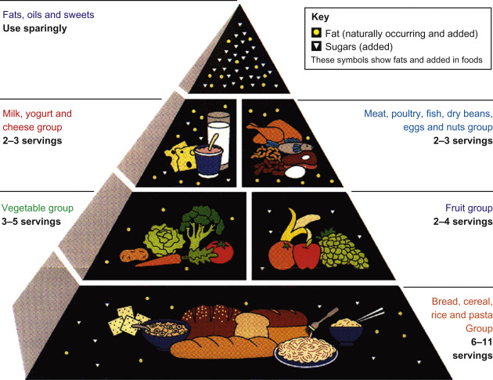

In 2005, the USDA introduced MyPyramid, an updated version of the Food Guide Pyramid. Food groups were depicted in ascending vertical bands that emphasized the right proportions of food groups. An image of a person walking up a flight of stairs flanked the pyramid to emphasize activity. Instead of servings, quantities were measured in cups and ounces.
One cup is equivalent to 250ml
One ounce is about 28.35g
One pound is 454g
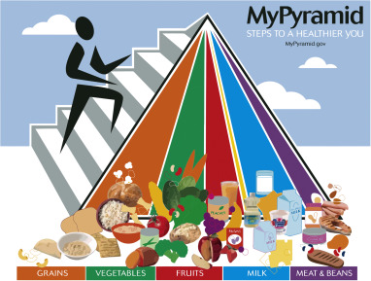

Other food guide pyramids followed, including the Mediterranean and Asian. Each of the ethnic food guide pyramids added, deleted, or substituted culturally correct foods with those in the USDA Food Guide Pyramid. For example, yogurt and goat milk products appeared in the Mediterranean Food Guide Pyramid, since intolerance to dairy products from cows is prevalent in this region of the world. Likewise, the Asian Food Guide Pyramid included soy products to replace the nutrients that are normally found in dairy products.
Additional food guide pyramids have been developed for children, seniors, vegetarians and a number of other groups to meet their specific nutritional needs. Yet, in 2011, after six years, the USDA replaced the Food Guide Pyramid with the nutrition guide MyPlate. MyPlate focusses on increasing fruits and vegetables at mealtime by encouraging filling half of an individual plate with antioxidant sources. Food guide pyramids are still used in other parts of the world and by some specialty groups.
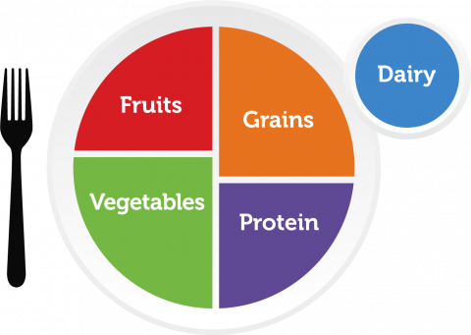 MyPlate
Interpretation of MyPlate
- Fruits should make up slightly less than one-quarter of your plate. It is recommended to choose fruits in their whole, unprocessed form as much as possible. Juicing strips the beneficial fiber from fruit, making it a sugary drink that can cause blood sugar spikes and weight gain.
- Vegetables should make up at least one-quarter of the plate. The best way to enjoy them is by having lots of different kinds during the day and week because all vegetables have a different balance of vitamins and minerals so, the more varieties being eaten, the more nutritional bases that will be covered.
- Lean protein should make up one-quarter of a person’s plate. Lean protein sources are lower in fat and calories and include plant-based proteins such as legumes, nuts and seeds, tofu, lean meat, egg, fish, lean turkey, skinless chicken breast.
- Grains should make up one-quarter of the plate. All grains count, but whole grains provide the most fiber, vitamins and minerals. MyPlate recommends getting at least half of grains from whole grains.
- Aim for 1 serving of dairy per meal (3 cups daily). Replace foods high in saturated fat with foods high in monounsaturated ad polyunsaturated fats can help boost heart health. Choose fat-free or low-fat (1%) varieties as often as possible.
- Try to use liquid oils daily: they contain unsaturated fats which are heart-healthy fats. They are plant or fish-based; examples include sunflower seed oil, olive oil, almonds oil, canola oil, salmon oil, groundnut oil, cod liver oil, salmon oil.
- Cut back on added sugars. What you leave off a plate is important. From coffee, beverages to tomato sauce, people should be conscious on added sugar intake. Ingredients list and nutrition facts label should be read. Drinking of more water in place of beverages that have added sugar is recommended by MyPlate. Also, substituting sugary desserts like cake or cookies can also assist in reducing sugar intake from diet.

Benefits of the food guide system
Showed variety
The Food Guide Pyramid emphasized the importance of eating a balanced, varied diet by depicting five main food groups: grains, fruits, vegetables, dairy products and other proteins, including meat, fish, beans, nuts and eggs. Included with each food group were recommended servings per day, which communicated the idea that it's healthy to eat a variety of foods daily rather than getting most of your calories from just one or two of the groups -- a concept also communicated by the MyPlate guidelines.
Set limit
The tip of the Food Guide Pyramid depicted fats, oils and sweets and recommended limiting them to 100 to 300 calories out of an individual total daily calories. Although some fats, such as olive oil, have proven benefits for cardiovascular health, many Americans do eat unhealthier fats and sweets in excess, both of which can negatively affect heart health. In that regard, the recommendation to limit fats and sweets was valid.

Easy to Understand
By using a pyramid, the USDA was able to immediately imply that foods near the bottom of the pyramid were "good" and should be major fixtures of most people's diets, and foods nearer the tip of the pyramid were "bad" and should be limited or avoided.
Showed examples
The Food Guide Pyramid appealed to people's visual interest by showing examples of foods that might be healthy choices from each main group. Although not all depictions were of equally healthy foods, many items shown were significant sources of essential vitamins and minerals. Some of the healthiest foods shown were whole-grain bread, milk, eggs, fish, nuts, beans, fresh fruits like apples and oranges, and fresh vegetables like broccoli and leafy greens. Seeing examples of what you "should" be eating helped you think about healthy meal planning and what to pick when you had more than one option.

Criticisms of the US Food Guide System
1. It did not differentiate between whole grain foods and refined products thus not taking into consideration their different nutritional value
2. Conveyed decrease or limit of fat in the diet thus ignoring that not all fats are the same; some dietary fats (unsaturated fats) are heart-healthy so they should be added to the diet to replace other fats such as saturated and trans fats
3. US Food Guide System emphasised eating carbohydrates not considering that there are various types of carbohydrates (sugars); simple sugars are found in pastries like cakes, cookies, doughnuts and should be limited in consumption while complex carbohydrates found in whole grains are nutritious so the consumption should be encouraged.

FOOD-BASED DIETARY GUIDELINES - NIGERIA
Official name
Food-based dietary guidelines for Nigeria – a guide to healthy eating.
Publication year
Nigeria began developing its dietary guidelines in 2000 and published them in 2001.
Process and stakeholders
The guidelines were developed by the Ministries of Health, Agriculture and Rural Development and Information; universities, the World Health Organization, Helen Keller International, International Institute of Tropical Agriculture, and pediatrics and nutrition societies.
They have been published in four languages: Hausa, Yoruba, Igbo and English.
Intended audience
The dietary guidelines apply to all healthy Nigerians and include recommendations for different population groups.

Food guide
The Nigerian food guide is a food pyramid divided into five food groups. At the bottom are bread, grains and tubers, followed by vegetables and fruits. Both groups are to be eaten at every meal. Eggs, fish, meat and dairy are on the third level, and are to be eaten in moderation. Oils and fats should be eaten sparingly according to the pyramid, with confectionery limited to rare occasions. A glass of water is placed outside of the pyramid with the advice to always drink plenty of water.
Messages
- Total food intake should take into consideration a person’s level of physical activity.
- Individuals who do manual work need to consume more food than those who do sedentary work.
- Limit fat intake from animal foods.
- The diet should contain as wide a variety of foods as possible, e.g. cereals, legumes, roots/tubers, fruits, vegetables, fish, lean meat, local cheese (wara).
- Limit intake of salt, bouillon cubes and sugar.
Liberal consumption of whatever fruit is in season is encouraged

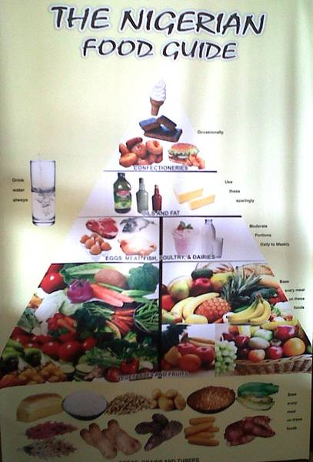

THE NEW MEDITERRANEAN DIET
The new Mediterranean Diet is based on expanded traditional model by incorporating a wider variety of global foods that share the same nutritional principles available in countries that border the Mediterranean Sea like Crete, Greece, Southern Italy, France and Spain. The foundation for this healthy diet includes:
- diet high in healthy plant foods
- diet low in animal products and meat
- fish and seafood at least twice a week
You can include a mix of fresh, frozen, dried, and canned fruits and vegetables, but check package labels for added sugar and sodium. Along with food, the Mediterranean diet emphasizes the need to spend time eating with family and physical activity.
You can base your diet on these foods:
- Vegetables: tomatoes, broccoli, kale, spinach, onions, cauliflower, carrots, Brussels sprouts, cucumbers, potatoes, sweet potatoes, turnips
- Fruits: apples, bananas, oranges, pears, strawberries, grapes, dates, figs, melons, peaches
- Nuts, seeds, and nut butters: almonds, walnuts, macadamia nuts, hazelnuts, cashews, sunflower seeds, pumpkin seeds, almond butter, peanut butter
- Herbs, spices, condiments: sea salt, pepper, turmeric, cinnamon, cayenne pepper, oregano, garlic, basil, mint, rosemary, sage, nutmeg, cinnamon, pepper
- Legumes: beans, peas, lentils, pulses, peanuts, chickpeas
- Whole grains: oats, brown rice, rye, barley, corn, buckwheat, whole wheat bread and pasta
- Fish and seafood: salmon, sardines, trout, tuna, mackerel, shrimp, oysters, clams, crab, mussels
- Poultry: chicken, duck, turkey
- Eggs: chicken, quail, and duck eggs
- Dairy: cheese, yogurt, milk
- Healthy fats: extra virgin olive oil, olives, avocados, and avocado oil
- Seafood: salmon, sardines, mackerel, trout, shrimp, mussels
- Dairy products: Greek yogurt, yogurt, milk

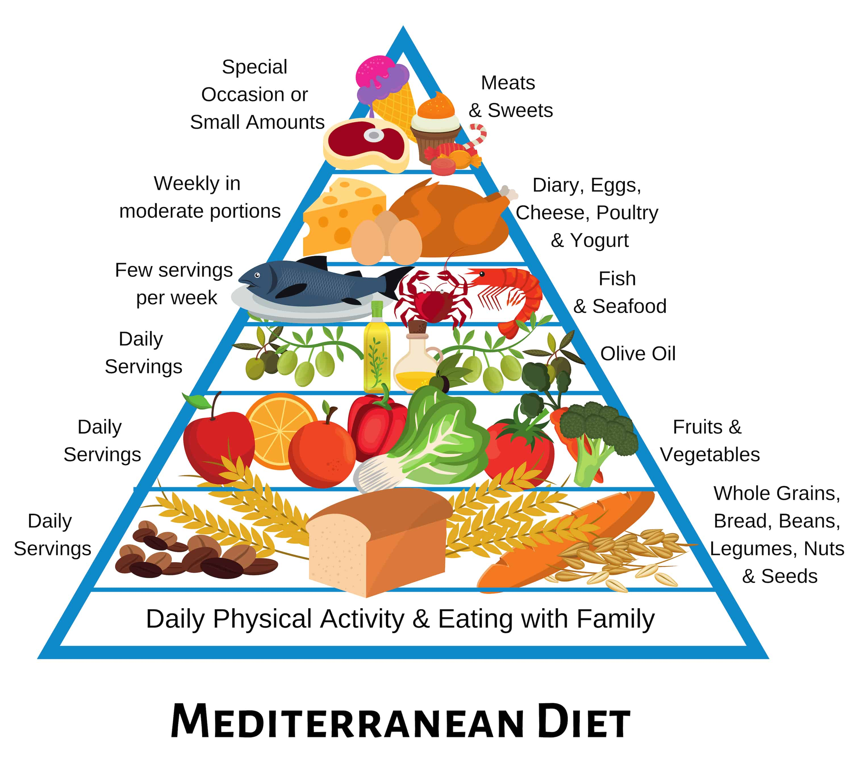

ANTINUTRIENTS
The availability of a nutrient in any food will depend not only on its chemical and physical form, but also on other substances present in the food which could also be nutrients or non-nutrients
Antinutrients are compounds or substances found in plant-derived foods that interfere with absorption and proper functioning of nutrients in the body leading to deficiencies of the nutrients if the foods are consumed excessively. They are produced by plants as a defence mechanism against bacterial infections and predators like insects, parasites and humans. They deter predators by making the plant less appealing or harmful to consume, ensuring their survival and reproduction ability. A compound exhibits antinutrient property when ingested by an animal by binding certain nutrients or enzymes needed for digestion.
Examples of antinutrients and their effects
1) Protease inhibitors like trypsin inhibitor in soybeans which inhibit trypsin, pepsin and other proteases in the gut preventing digestion and absorption of proteins and amino acids.
2) Lipase inhibitors which interfere with enzymes such as lipases, which catalyse hydrolysis of some fats
3) Amylase inhibitors in beans, which prevent the action of enzymes that break the glycosidic bonds of starches and other complex carbohydrates preventing the release of simple sugars and absorption by the body
4) Glucosinolates and goitrogens in cruciferous vegetables like cabbage, broccoli prevent absorption of iodine which may then interfere with thyroid absorption thereby causing goitre (an enlarged thyroid gland). Those already with iodine deficiency or a condition called hypothyroidism are most susceptible.
5) Lectins in legumes, whole grains can interfere with the absorption of calcium, iron, phosphorus and zinc.
6) Oxalates in green leafy vegetables, tea, beans, nut, sugar beets etc. can bind to calcium and prevent it from being absorbed. Also, excess oxalate combines with calcium to create kidney stones and crystals, which can damage the kidneys and cause them to stop functioning. This is referred to as renal failure.
7) Phytates (Phytic acid) found in whole grains, seeds, legumes, some nuts can decrease the absorption of iron, zinc, magnesium and calcium.
8) Saponins in legumes, whole grains, tea, onions, garlic, potatoes, etc. interfere with normal nutrient absorption like magnesium, iron, zinc, calcium, vitamin A, vitamin E. Saponins got their name from their ability to form soap-like foams in water. They are responsible for the foamy substance seen when beans are soaked. Saponins impair digestive enzymes which reduce the body’s ability to digest and absorb proteins.
9) Tannins found in foods like tea, coffee, legumes, mango, grapes, cocoa, grape juice, grape wine, cocoa bind to iron and block its absorption into the body from the intestines. Tannins also reduce protein digestibility by blocking enzymes needed for its digestion. Grape tannins are mainly found in seeds and skins so, when grapes are pressed in the winery, seeds, skins and stems soak in the grape juice and release tannin (how long they soak for determines the amount of tannin that will be present in the wine). Iron and zinc absorption are reduced when tannin bind to them.
10) Cyanogenic glycosides found in cassava, lima beans, sorghum, bitter almonds, apple seeds, bamboo shoot are converted into cyanide causing cyanide poisoning or irreversible neurological conditions in the long term.
11) Phytoestrogens are found mainly in soy products, they are also in some fruits like pears and plums; vegetables like garlic, onions. They may behave like endocrine disruptors by changing the way hormones function in the body.

It is not known how much nutrient loss occurs in our diets due to antinutrients and the effects vary among individuals based on their metabolism and how the food is prepared and cooked. To lower the risk of interference with antinutrients, avoid eating large quantities of foods containing antinutrients at one meal and eat a balanced diet throughout the day with a variety of foods, eg instead of eating two cups of oatmeal with milk for breakfast, choose one cup with milk and one cup of berries. Another strategy could be altering the timing of eating foods with antinutrients, e.g. drinking tea between meals instead of with a meal to reduce the chances of iron being poorly absorbed, taking calcium supplement a few hours after eating a high fiber wheat bran cereal meal that contains phytate.
Note: Many antinutrients can be removed or deactivated by soaking, sprouting, fermentation, boiling and so on.
Presence of antinutrients in food does not mean it is unhealthy or should be avoided as antinutrients may also exert health benefits. Many antinutrients have antioxidant and anticancer effects. Phytates have been found to lower cholesterol, slow digestion and prevent sharp rises in blood sugar. Many boost immune system by slowing or preventing the growth of fungi, bacteria and viruses that can cause illness. All antinutrients sources provide dietary fibre which has health benefits like supporting blood sugar balance, lowering cholesterol levels and supporting healthy digestion

NUTRIENT-NUTRIENT INTERACTION: This refers to the impact of one nutrient on another nutrient’s bioavailability. Nutrient bioavailability includes two important components, absorption and utilization. Absorption is the process by which a nutrient moves from the intestine into the body. Utilization of the absorbed nutrients include transport to various parts of the body, assimilation by cells and conversion to biologically active form. Nutrient-nutrient interaction may either inhibit or enhance nutrient absorption or utilization. High or low levels of one or more nutrients may affect bioavailability of other nutrient(s). Interaction can affect all the major categories of nutrients.
Examples of nutrient-nutrient interaction
- Protein interaction with other nutrients: Various protein bind and transport certain vitamins and minerals including iron, copper, magnesium, calcium, vitamin A, vitamin D, fat, etc. Inadequate protein intake may impair the function of these nutrients
- Carbohydrate-thiamine interaction: Carbohydrates in the body require thiamine for their metabolism, excess carbohydrate in diet increase thiamine requirement and also helps in fat and protein functioning.
- Dietary fibre-mineral interaction: High amount of dietary fibre lead to reduced rate of absorption of several minerals like calcium and iron resulting in increased excretion of such minerals.
- Fat- other nutrient interaction: Adequate intake of dietary fat and zinc is necessary for the absorption and utilization of vitamin A. Excess fat in the diet decreases thiamine requirement, addition of essential fatty acid to a low pyridoxine diet protects against pyridoxine deficiency.
- Interaction of vitamin A with other nutrients: The bioavailability of vitamin A is dependent on several binding proteins which require sufficient intake of protein for their manufacture, inadequate protein intake may result in vitamin A deficiency. Adequate intake of dietary fat and zinc is necessary for vitamin A absorption and utilization. Vitamin A is believed to be important in iron metabolism because the former causes anaemia. Excess vitamin A interferes with the absorption of vitamin K, a fat-soluble vitamin that is needed for blood clotting.
- Vitamin E, a fat soluble antioxidant, protects omega-3 fats from oxidation. Conversion of vitamin B12 from its non-active form into its biologically active form requires vitamin E, hence, vitamin E deficiency may lead to vitamin B12 deficiency.
- Niacin interaction with other nutrients: niacin supply comes from conversion of the amino acid tryptophan so, tryptophan deficiency can increase risk of niacin deficiency. Also, this conversion requires the presence of thiamine and pyridoxine
- Interaction of folate with other nutrients: Vitamins B1, B2 and B3 must be present in adequate amounts to enable folic acid to undergo metabolism in the body.
- Interaction of vitamin C with other nutrients: Vitamin C significantly enhance iron absorption, thus without vitamin C, the body may not be able to utilise iron effectively leading to iron deficiency anaemia (IDA). Excessive intake of vitamin A is less toxic to the body when vitamin C is available. Vitamin C is required to keep vitamin E in its metabolically active form.
- Vitamin D and other nutrients interaction: Vitamin D enhance absorption and storage of calcium thereby of importance in the prevention of osteoporosis and other bone-related problems. It also stimulates the absorption of phosphorus.
- Iron- zinc interaction: iron transport relies on the presence of copper,
- Zinc-copper interaction: High zinc intake enhance the production of copper-binding protein which trap copper thus, preventing its absorption
- Iron and vitamin A: impairment of mobilization of iron from the liver and/ or incorporation of iron into the erythrocyte when vitamin A status is low.
- Iron and iodine: The key steps in iodine metabolism are iron dependent so, adequate iron status is a prerequisite for effective iodine treatment of goitre.
- Iron and manganese: High levels of manganese interfere with iron metabolism
- Zinc and vitamin A: zinc deficiency impairs Vitamin A metabolism.
- Calcium – other nutrient interaction: Vitamin D accelerates the absorption of calcium from gastrointestinal tract. High potassium intake reduces the urinary excretion of calcium while high intakes of sodium, caffeine, or protein cause increase in urinary excretion of calcium. Calcium decreases the absorption of heme and nonheme iron. Magnesium and calcium compete with each other for intestinal absorption, so, calcium supplements should not be taken at the same time as magnesium supplements.

NUTRIENT-DRUG INTERACTION
Drug is defined as a substance used in the diagnosis, treatment, or prevention of a disease, or component of a medication. There are many dramatic results and problems that may be caused by food/nutrient-drug, drug-drug, and alcohol-food-drug interactions, and these vary from person to person. Drug-nutrient interactions involve changes to a drug caused by a nutrient, or changes to a nutrient as a result of the drug. A food-drug interaction is the effect of food on a medication. Such interactions raise concerns that medications may lead to nutritional deficiencies or that the diet may change how a medication works. This does not mean that an individual taking a medication will need to use a vitamin and or mineral supplement. In excessive amounts, vitamins and minerals act like drugs instead of nutrients. Nutrients in excessive amounts may interact with other nutrients or may even be toxic.
There is little chance that taking a medication for a short time, such as a ten-day treatment, will affect your nutritional status. However, use of some medications for months or years may affect the nutritional health.
Children, older adults, pregnant women, people who are poorly nourished, and people with chronic disease are at greater risk of medications affecting their nutritional health. Changing the diet to include more foods rich in vitamins and minerals is preferred to taking vitamin or mineral supplements. In fact, vitamin and/or mineral supplements taken in excess can affect how a medication works.

EFFECTS OF FOOD ON DRUG INTAKE
Drug Absorption: Food or nutrients in the stomach or intestine may act to reduce the absorption of a drug by delaying digestion, binding to minerals found in the food, or adhering to food particles. In other cases, the food may promote drug absorption.
Drug Breakdown: Food may act to enhance or inhibit the metabolism of certain drugs in the body.
Drug Excretion: Food and nutrients may act to alter the reabsorption and excretion of drugs from the kidney.
Certain food components like caffeine or alcohol can lead to the enhancement or opposition of the effects of some drugs.

EFFECTS OF DRUGS ON FOOD AND NUTRITION
Nutrient Absorption: Certain drugs may increase, decrease, or prevent nutrient absorption in the gut.
Nutrient Breakdown: Drugs may speed up the metabolism of certain nutrients, resulting in higher dietary requirements of that particular nutrient.
Nutrient Excretion: Drugs can increase or decrease the urinary excretion of nutrients.

SIDE EFFECTS OF DRUGS AND OTHER MEDICATIONS
Taste and Smell Alterations: Some drugs may alter one’s ability to taste and smell certain foods. Food intake may be affected due to alteration of taste sensation, reduced acuity to taste, or undesirable aftertaste.
Gastrointestinal (GI) Effects: Some drugs can cause irritation to the digestive tract that includes stomach upset, nausea, vomiting, diarrhea, constipation, ulcers, and gastric bleeding. Some drugs may alter gastric acidity and damage mucosal surfaces leading to decreased nutrient absorption.
Appetite Changes: Alterations in appetite may include suppression or stimulation of hunger leading to weight loss or weight gain.
Organ Toxicity: Since many drugs must pass through the liver and kidney upon excretion, hepatotoxicity (liver damage) and nephrotoxicity (kidney damage) are of primary concern.
Metabolic Effects: Some drugs may affect blood glucose levels by stimulating the production of glucose or inhibiting its uptake. Other drugs may inhibit insulin secretion, decrease insulin sensitivity, or increase insulin clearance from the blood. This may lead to conditions known as hyperglycemia (high blood glucose), hypoglycemia (low blood glucose), or diabetes. Other medications may lead to abnormal lipid levels, causing elevated cholesterol or triglycerides.
Examples
- Medications that decrease appetite or cause nausea, vomiting, an unpleasant taste, or dry mouth can affect nutritional health by causing poor food intake.
Appetite suppressants are medications that directly affect food intake by depressing appetite.
Example: Several cancer medications and treatments may cause nausea, vomiting, sore, or dry mouth resulting in poor food intake.
- Medications that decrease nutrient absorption;
Laxatives can decrease the absorption of many vitamins and minerals. Laxatives cause food to move rapidly through the body causing poor nutrient absorption.
Example: Some anticonvulsants can decrease folate absorption.
- Medications can slow down nutrient production.
Example: Vitamin K is produced by bacteria in the intestines. Antibiotics kill harmful bacteria, but they can also kill helpful bacteria, including bacteria that produce vitamin K in the intestine.
- Medications can interfere with the body’s ability to metabolize nutrients.
Example: Some anticonvulsants alter the activity of liver enzymes, causing increase metabolism of folate, vitamin D and vitamin K.
- Medications can increase the loss of a nutrient.
Example: Diuretics remove excess fluid from the body. Some diuretics may also increase loss of potassium along with fluids. Potassium is very important in proper functioning of the heart and other muscles.

FOOD/ NUTRIENT-DRUG INTERACTIONS
Food and nutrients can also alter a medication’s effectiveness in many ways.
- Food can increase or decrease the absorption of a drug. Absorbing less than the intended dose may decrease the effect of the drug. Absorbing more than the intended dose increases the chance for an overdose effect.
Examples- Dietary calcium can bind to the antibiotic tetracycline. As a result, the body does not absorb the amount of antibiotic intended.
- Drugs are absorbed more quickly into the body when the stomach is empty. Having food in the stomach will slow down a medication’s absorption. Sometimes a medication should be taken with food. Other medications should be taken on an empty stomach, one hour before or two hours after eating. It is important to read the directions to see if a medication should be taken with or without food.
- Foods or nutrients may interfere with a drug’s metabolism or a drug’s action in the body.
Examples- Aged and fermented foods contain a chemical called tyramine that interacts with a medication, monoamine oxidase inhibitor. This interaction can result in dangerously high blood pressure.
- Foods or nutrients may be needed for the removal of a medication from the body.
Example: Liver enzymes prepare medications for removal from the body. These enzymes require nutrients to work properly. If required nutrients are not present, medications may stay active in the body longer than they are supposed to.
- Green, leafy vegetables, which are high in vitamin K, can decrease how well aspirin thins the blood. Consuming consistent amount of green-leafy vegetables each day will decrease this interaction.
- Grapefruit juice alters the way the body absorbs cholesterol-lowering drugs in the blood. It can cause these drugs to be absorbed in higher than normal amounts resulting in a greater risk of side effects.
- Calcium channel blockers are prescribed for high blood pressure and are also affected by grapefruit juice. Grapefruit juice changes the way this drug breaks down in the body and may cause overly high levels of the drug in the blood, raising the risk of side effects.
- Dairy products such as milk, yogurt and cheese decrease the absorption of antibiotics. Try to eat meals one to two hours before taking these to avoid this interaction.
- Alcohol and medications do not mix well. Alcohol can adversely affect medications as well as nutrients. Alcohol can slow down the body’s metabolism. As a result, medications can stay active in the body longer than they were supposed to. In some cases, mixing alcohol and medications can be fatal. Alcohol affects insulin or oral diabetic pills. Alcohol prolongs the effects of these drugs, thus result in low blood sugar. Alcoholic beverages should be avoided when taking prescription or over-the-counter medications.
- Moderate pain reliever drugs with acetaminophen should not be taken with alcohol because it has a higher chance of causing severe liver damage. Antihistamines, should not be taken with alcohol because it will cause increased drowsiness.

